Z:\WORK\852168\Illustration\New folder\Button_V3.emf

Coupa

**Create a Requisition for Multi Destination**



1

Click <https://kpmgus.coupahost.com/> to open your Coupa homepage.



2

To search for catalog items, navigate to the **Additional Stores** on the bottom right of your home page and click on **Staples Promotional Products** tile. 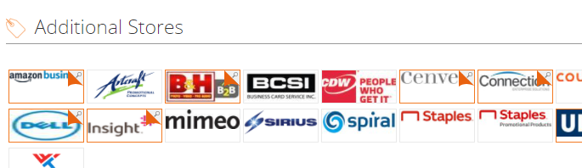



3

Input items and quantity add to Cart. Then follow instructions on the Gifting Solutions Tab(see below)

Review shopping cart and select Checkout.



4

Select Shipping Method and click **Continue to Requisiton** which will bring back to Coupa where select Proceed to Checkout.

* Download and complete [**this spreadsheet**](https://spponeimages.azureedge.net/prod/fa3f8ef7-c6f4-4e81-8530-bee73c5a27a9Calendar%20Multiple%20Destinations.xls?v=0), by providing information in the highlighted columns.
* Email the spreadsheet to [kpmgmultiship@staples.com](mailto:kpmgmultiship@staples.com), include the PO number. If using the PO number in the email you will need to wait until the requsition is fully approved.
* **In Coupa** in the General Info section under Attachments TEXT, input “**HOLD FOR MULTI DESTINATION SHIP TO ADDRESSES**” and check off the box Send to supplier.

